**Create index.html on 3 different repository’s and access from Jenkins server by creating 3 job respectively**

**1.Create 3 private repo—repo1 repo2 and repo3**

**2.In all 3 repo and index.html file is pushed and it reads as “This is repo1 master branch index file”, “This is repo2 Q2-2024 master branch index file”, “This is repo3 Q2-2024 branch index file” respectively.**

**3.Launched a Jenkin server using apache-tomcat server and Jenkins war file**

**4.Using URL : 18.226.165.23:8080/Jenkins logged into Jenkins UI**

**5.Created Job1—**

* **New Item**
* **Freestyle project**
* **Ok**
* **As all repo are private created credentials**

1. **Manage Jenkins-Credentials-Username&password-global**
2. **Give username & Password will be git token update**
3. **Update Id and description**
4. **Add**

* **Go inside your Job**
* **Select Discard old builds**
* **SCM-Git-Add URL of your repo1 and credential**
* **Delete workspace before any build starts**
* **Execute shell**

**sudo su -**

**yum install httpd -y**

**service httpd start**

**cp /root/.jenkins/workspace/Job1/index.html /var/www/html**

**cd /var/www/html**

**chmod -R 777 index.html**

* **Apply**
* **Save**
* **In same way Job2 and Job 3 was created with respective repo2 and repo3 URL’s**

**Job1**

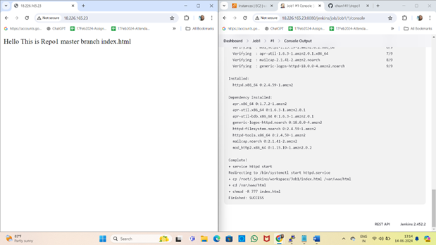

**Job2**

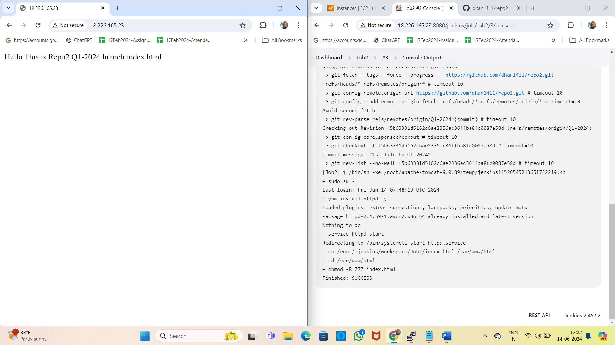

**Job3**

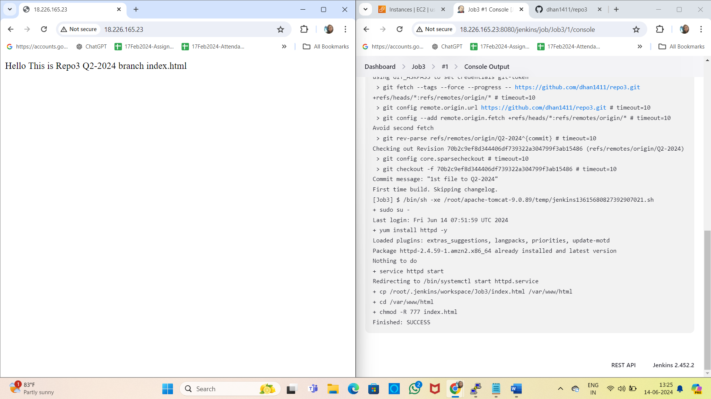

**Create 3 Repo each having index.html and if any changes are done in any repo ,Jenkins will generate auto builds using Github webhook**

**1.Create 3 private repo—repo1 repo2 and repo3**

**2.In all 3 repo and index.html file is pushed and it reads as “This is repo1 master branch index file”, “This is repo2 Q2-2024 master branch index file”, “This is repo3 Q2-2024 branch index file” respectively.**

**3.Launched a Jenkin server using apache-tomcat server and Jenkins war file**

**4.Using URL : 18.226.165.23:8080/Jenkins logged into Jenkins UI**

**5.Created Job1—**

* **New Item**
* **Freestyle project**
* **Ok**
* **As all repo are private created credentials**

1. **Manage Jenkins-Credentials-Username&password-global**
2. **Give username & Password will be git token update**
3. **Update Id and description**
4. **Add**

* **Go inside your Job**
* **Select Discard old builds**
* **SCM-Git-Add URL of your repo1 and credential**
* **Build trigger-Github hook trigger**
* **Delete workspace before any build starts**
* **Execute shell**

**sudo su -**

**yum install httpd -y**

**service httpd start**

**cp /root/.jenkins/workspace/Job1/index.html /var/www/html**

**cd /var/www/html**

**chmod -R 777 index.html**

* **Apply**
* **Save**
* **Go to repo1 in git hub-repo setting -webhooks-Add webhooks**
* **Payload URL-http://18.226.165.23:8080/jenkins/github-webhook/**
* **Content Type-application/JSON**
* **Just push event**
* **Add webhook**
* **Do changes to repo1 and push those to github**
* **A build will be auto generated in Job1 due to github webhook**
* **In same way Job2 and Job 3 was created with respective repo2 and repo3 URL’s**

**Job1**

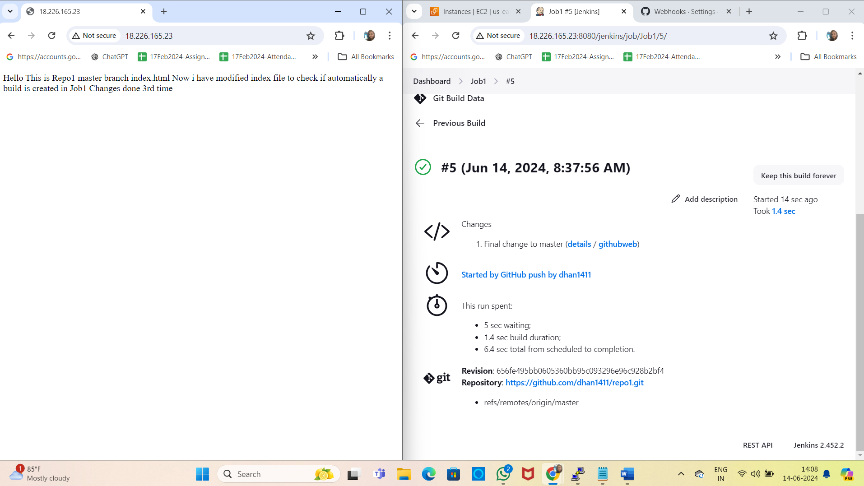

**Job3**

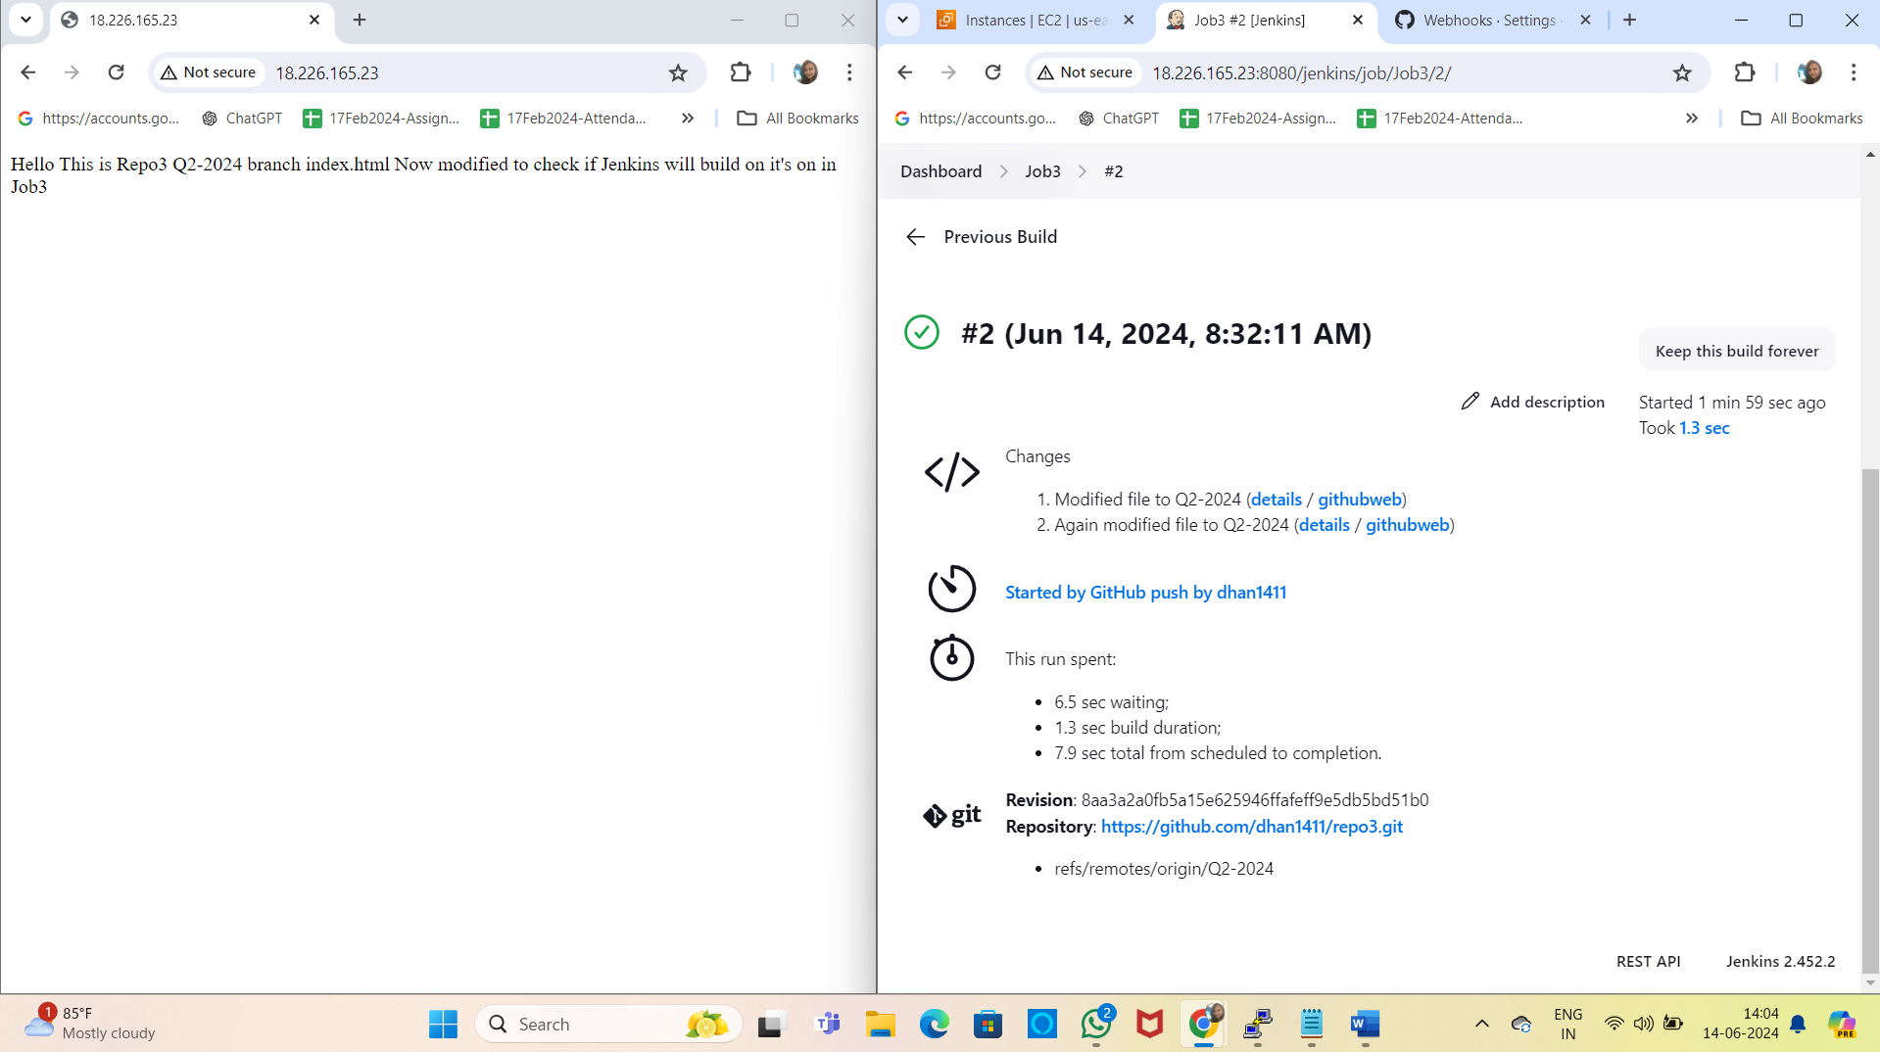

**Job2**

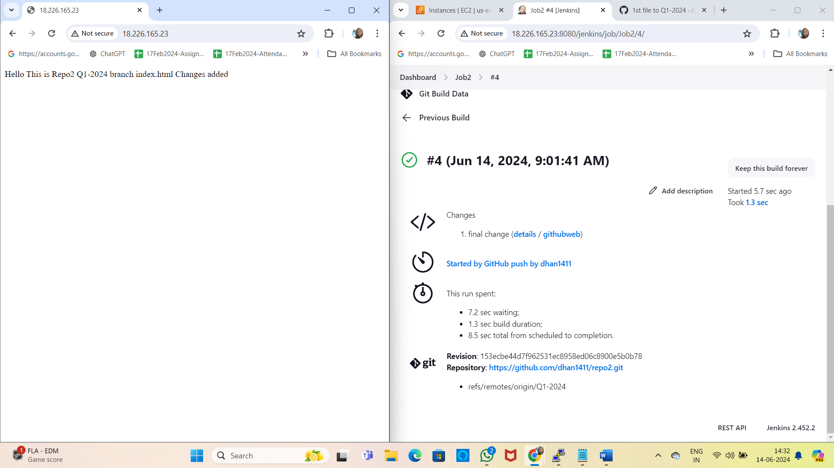

**Created Trigger Job in which all 3 Job’s were added for parallel execution. Changes in any one repo were getting reflected in trigger job as shown below**

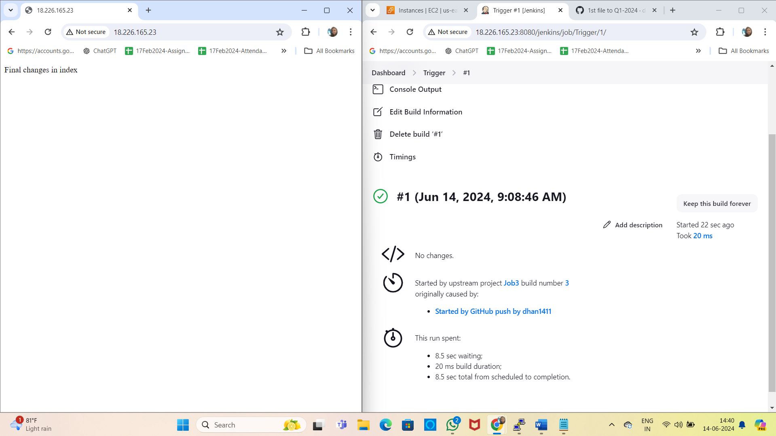

**Deploy War file from Jenkins server to two EC2 server where apache-tomcat is running**

* **Launch an EC2 instance which will be your Jenkins server**
* **Install Java first(here Java11 is installed for LTS Jenkins)**
* **Install apache-tomcat(wget** [**https://dlcdn.apache.org/tomcat/tomcat-9/v9.0.89/bin/apache-tomcat-9.0.89.zip**](https://dlcdn.apache.org/tomcat/tomcat-9/v9.0.89/bin/apache-tomcat-9.0.89.zip)**)**
* **unzip apache-tomcat-9.0.89.zip**
* **rm -rf apache-tomcat-9.0.89.zip**
* **chmod -R 777 apache-tomcat-9.0.89**
* **cd apache-tomcat-9.0.89**
* **cd webapps**
* **wget** [**https://get.jenkins.io/war-stable/2.452.2/jenkins.war**](https://get.jenkins.io/war-stable/2.452.2/jenkins.war)
* **cd ..**
* **cd bin**
* **./startup.sh**
* **Install git yum install git -y(as we will clone a repo)**
* **Install Maven wget** [**https://dlcdn.apache.org/maven/maven-3/3.9.7/binaries/apache-maven-3.9.7-bin.zip**](https://dlcdn.apache.org/maven/maven-3/3.9.7/binaries/apache-maven-3.9.7-bin.zip) **----to compile and package**
* **Unzip apache-maven-3.9.7-bin.zip**
* **Rm -rf apache-maven-3.9.7-bin.zip**
* **yum install maven -y**
* **mvn**
* **Go to web browser update** [**http://3.133.153.90:8080/jenkins**](http://3.133.153.90:8080/jenkins)
* **For initial admin password got to Jenkin server cd /root/.jenkins/secrets**
* **Cat initialadminpassword(here you will get your password)**
* **Your Jenkins UI will be opened update initialadmin password**
* **Install suggested plugins**
* **After plugins are installed give username, password, email id and name-save and continue**
* **Your Jenkins UI is ready for use**
* **Manage Jenkins-Tools**
* **Add Maven-Maven name(apache-maven-3.9.7) and Home(/root/** **apache-maven-3.9.7)**
* **Create a Job in Dashboard**
* **New item**
* **Name-Job1**
* **Freestyle project**
* **Ok**
* **Discard old builds**
* **SCM**
* **Git—Repo URL https://github.com/Shantanumajan6/project.git**
* **Branch Specifier-*/master**
* **Delete workspace before build starts**
* **Build steps**
* **Execute shell (rm -rf /root/.m2/repository)**
* **Ivoke Top level Maven targets(Maven version -** **apache-maven-3.9.7 Goals clean install)**
* **Install SSH server from available plugin**
* **Execute shell**
* echo 'private key’>>Test.pem
* chmod 400 Test.pem
* scp -i Test.pem target/LoginWebApp.war ec2-user@172.31.8.113:/home/ec2-user
* ssh -i Test.pem ec2-user@172.31.8.113 'sudo mv /home/ec2-user/LoginWebApp.war /root/apache-tomcat-9.0.89/webapps'
* **Apply**
* **Save**
* **Build Now(Check if success or failure of your build)**
* **Go to web browser :** [**http://13.59.134.185:8080/LoginWebApp**](http://13.59.134.185:8080/LoginWebApp)

